Name: Rodrigo Ignacio Rojas Garcia

Course: ECE 4310

Lab #4

Region Interaction

In this project the student was to implement interactive region growing. The student was provided with a built in Visual Studio project called “plus” which demonstrated several GUI and event handling techniques and region growing C code which demonstrated the region grow based on several predicates. The student was to use these two given pieces in order to complete the following requirements:

1. Program to visualize the region growing by coloring pixels as they join the growing region.
   1. Program should have a GUI option which allowed the user to select the color for pixels to join the region.
   2. Program should have an option that clears the result of a previous region grow, displaying the original image.
2. Program should have a menu option to grow the region in “Play” mode or in “Step” mode.
   1. In “Play” mode, a pixel should join the region each 1 ms.
   2. In “Step” mode, a pixel should join the region each time the user presses the key ‘j’.
   3. The program should allow the user to change between modes while a region is growing.
3. Program should use a dialog box to allow user to select values for two predicates for joining a region.
   1. First predicated is the absolute difference of the pixel intensity to the average intensity of pixels already in the region (To join, a pixel must be within this range).
   2. Second predicate is the distance of the pixel to the centroid of pixels already in the region (To join, a pixel must be within this range).
   3. Both predicates should be applied at the same time while growing the region.

All C code can be seen at the end of the report.

**REQUIREMENT I**

*GUI allowing user to choose a color from Color Palette:*

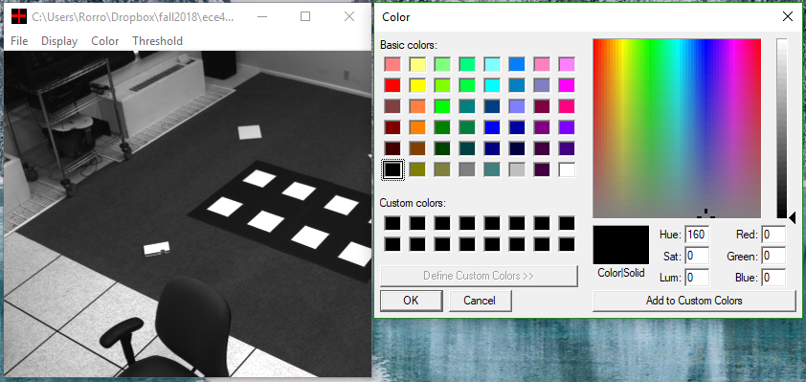

*Program showing option to clear the result of previous region grow:*

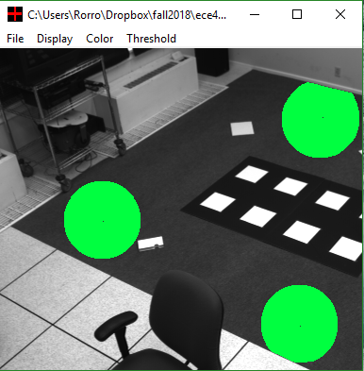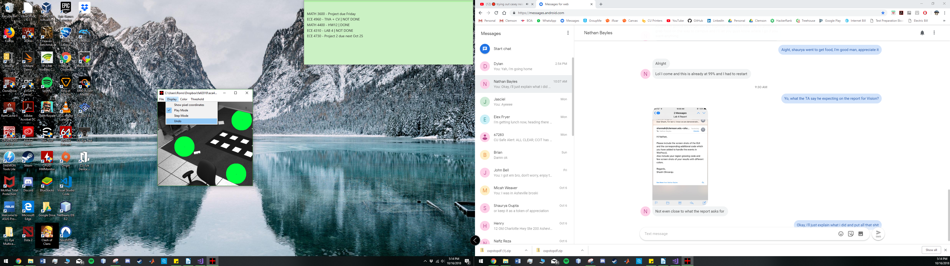

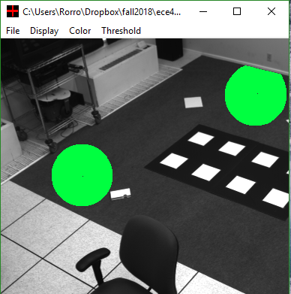

**REQUIREMENT II**

*Program showing “Play” mode*

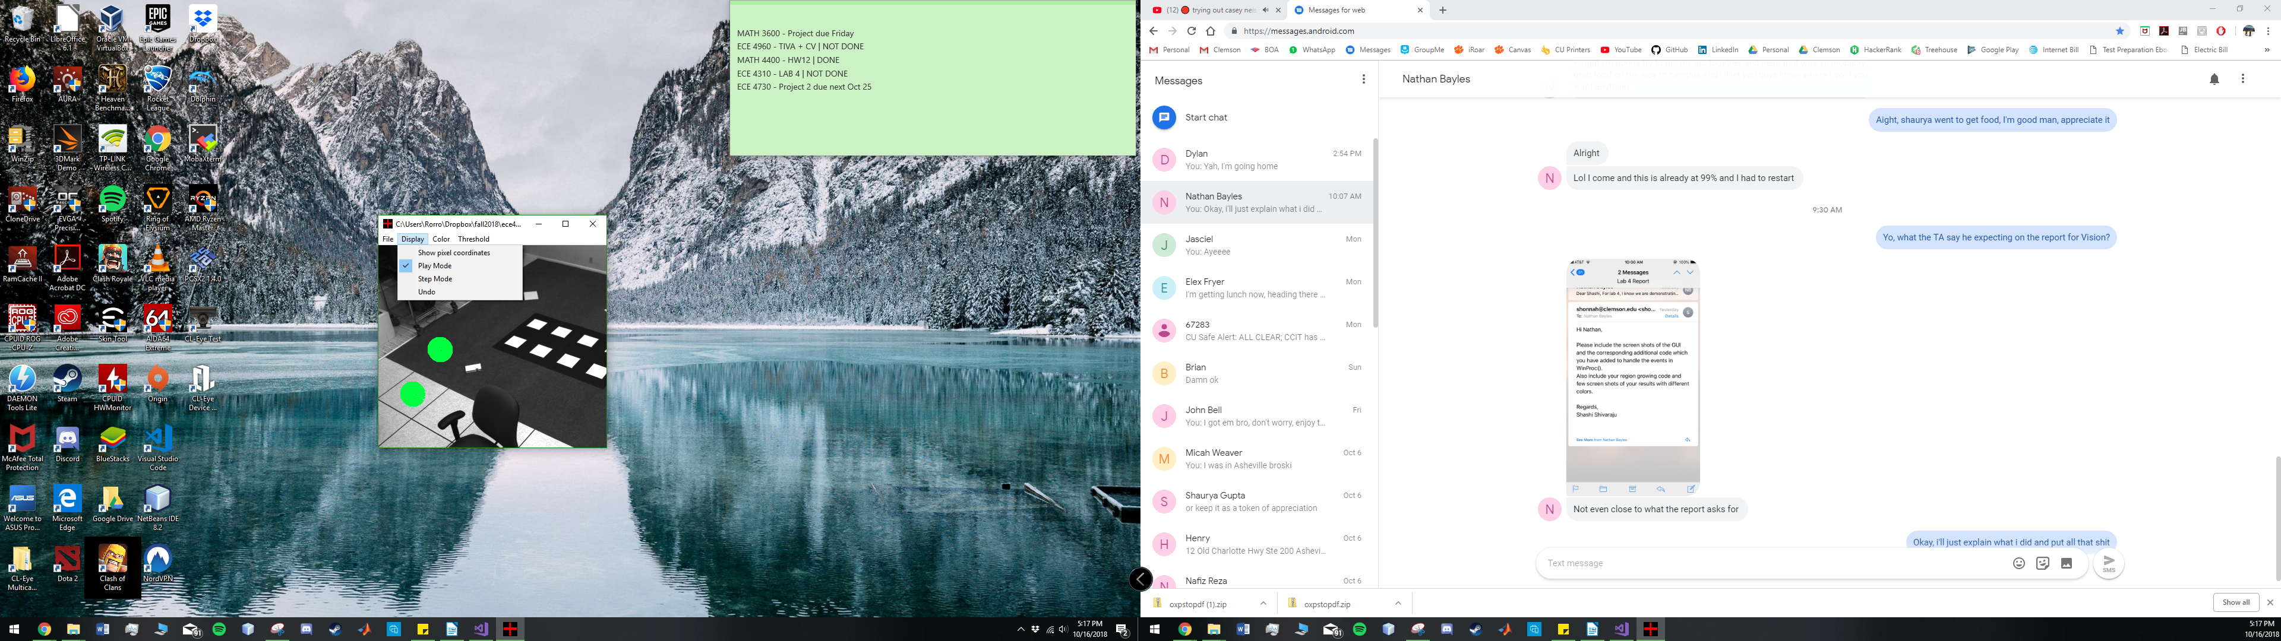

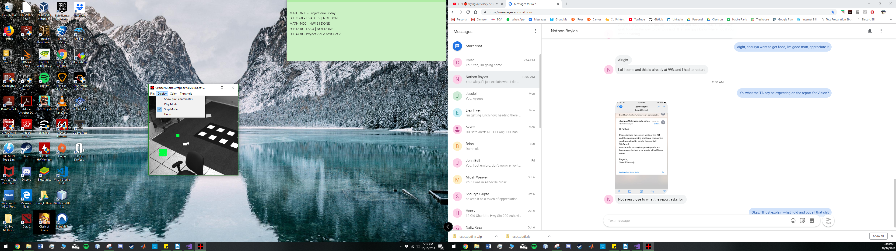*Program showing “Step” mode*

**REQUIREMENT III**

*Program showing Pixel Intensity Dialog Box :*

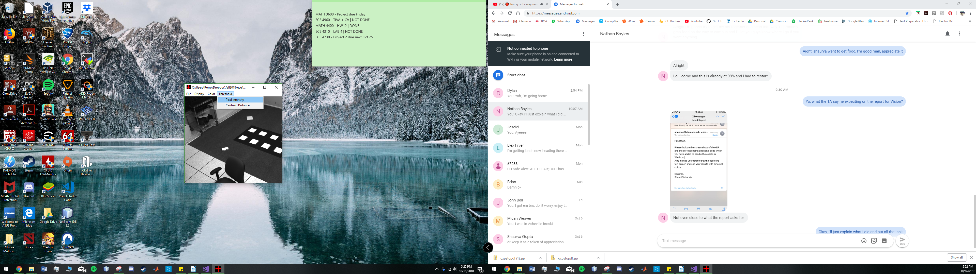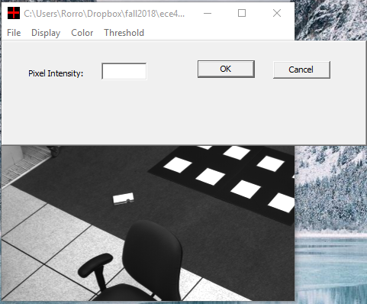

*Program showing Centroid Distance Dialog Box:*

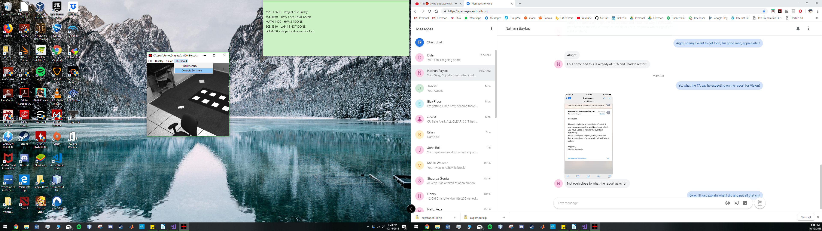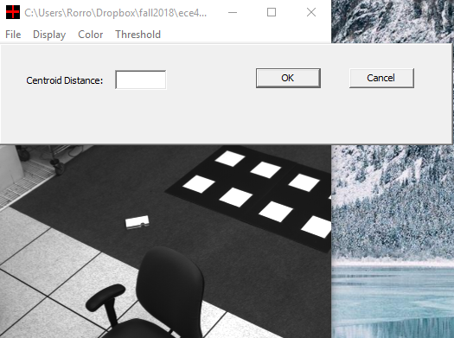

**RESULTS**

